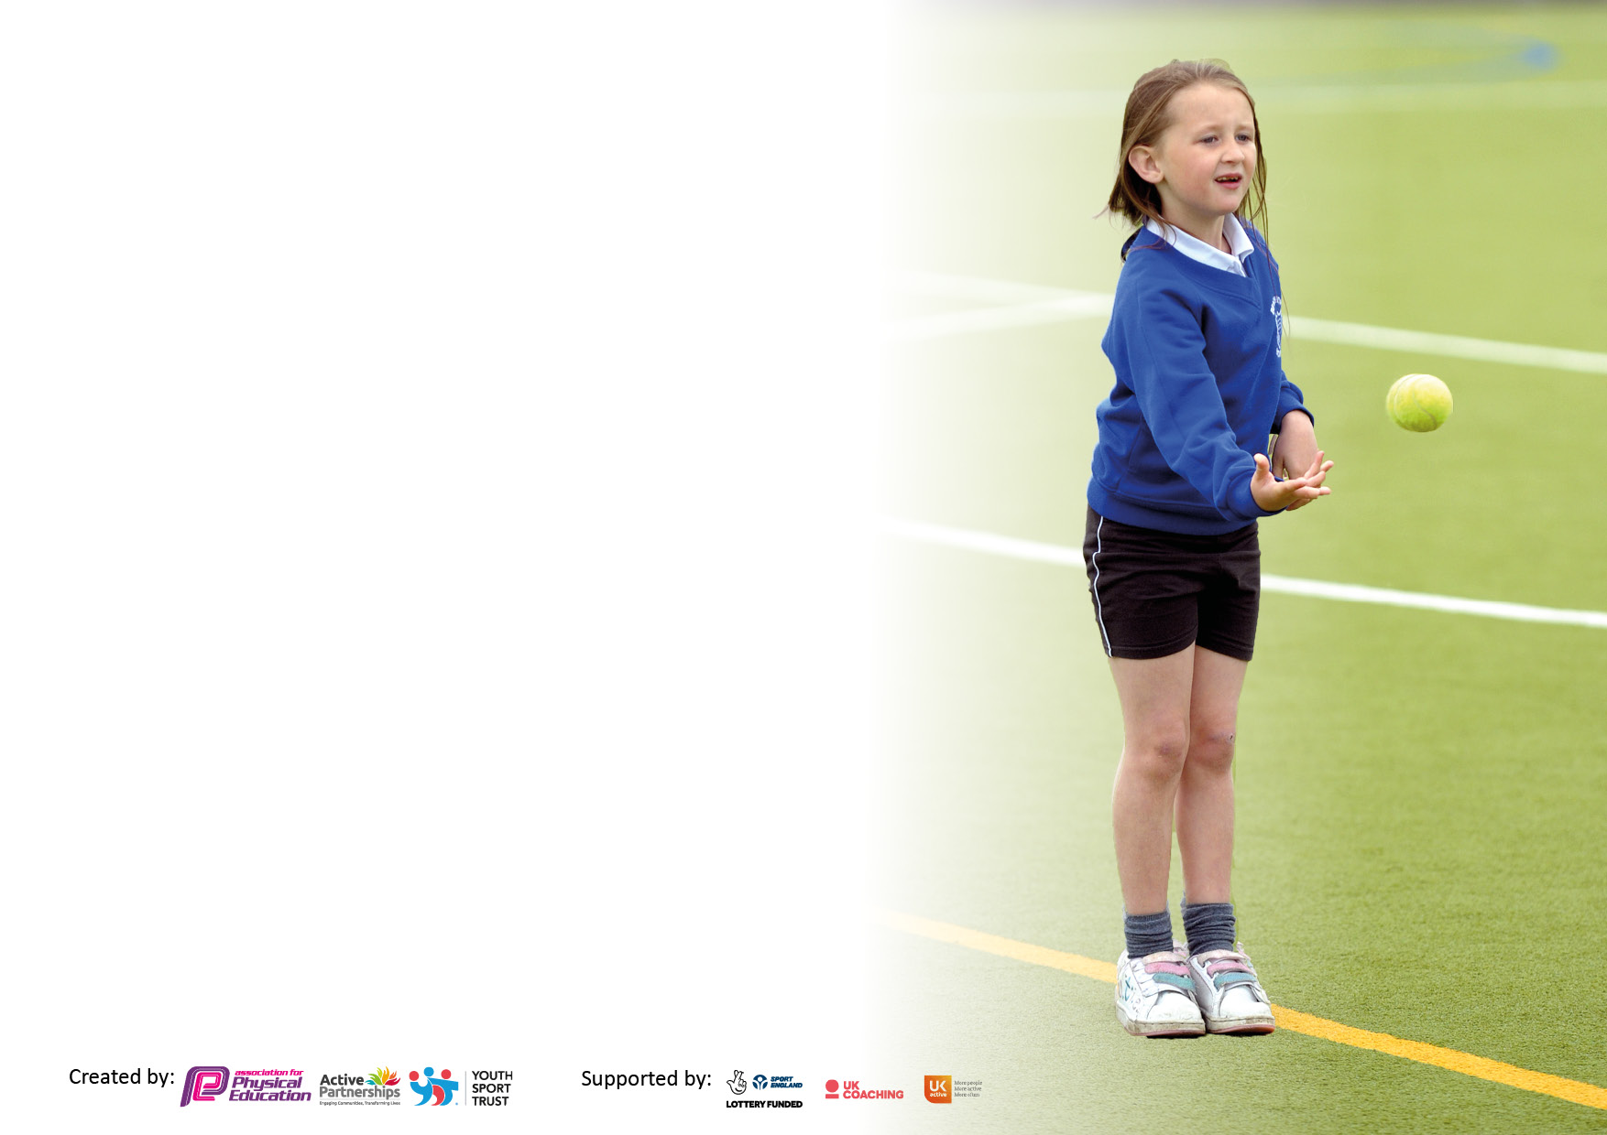

It is important that your grant is used effectively and based on school need. The Education Inspection Framework makes clear there will be a focus on **‘whether leaders and those responsible for governors all understand their respective roles and perform these in a way that enhances the effectiveness of the school’**.

Under the Quality of Education Ofsted inspectors consider:

**Intent** - Curriculum design, coverage and appropriateness

**Implementation** - Curriculum delivery, Teaching (pedagogy) and Assessment

**Impact** - Attainment and progress

To assist schools with common transferable language this template has been developed to utilise the same three headings which should make your plans easily transferable between working documents.

Schools must use the funding to make **additional and sustainable** improvements to the quality of Physical Education, School Sport and Physical Activity (PESSPA) they offer. This means that you should use the Primary PE and sport premium to:

* Develop or add to the PESSPA activities that your school already offer
* Build capacity and capability within the school to ensure that improvements made now will benefit pupils joining the school in future years
* The Primary PE and sport premium should not be used to fund capital spend projects; the school’s budget should fund these.

Pleasevisitgov.ukfortherevisedDfEguidanceincludingthe5keyindicatorsacrosswhichschoolsshoulddemonstrate animprovement.Thisdocumentwillhelpyoutoreviewyourprovisionandtoreportyourspend.DfEencouragesschools to use this template as an effective way of meeting the reporting requirements of the Primary PE and Sport Premium.

We recommend you start by reflecting on the impact of current provision and reviewing the previous spend.

Schools are required to publish details of how they spend this funding, including any under-spend from 2021/2022, as well as on the impact it has on pupils’ PE and sport participation and attainment. **All funding must be spent by 31st July 2023.**

We recommend regularly updating the table and publishing it on your website throughout the year. This evidences your ongoing self-evaluation of how you are using the funding to secure maximum, sustainable impact. Final copy must be posted on your website by the end of the academic year and no later than the 31st July 2023. To see an example of how to complete the table please click HERE.

**Details with regard to funding**

Please complete the table below.

|  |  |
| --- | --- |
| Total amount allocated for 2021/22 | £17400 |
| How much (if any) do you intend to carry over from this total fund into 2022/23? | £2544.39 |
| Total amount allocated for 2022/23 | £17400 |
| Total amount of funding for 2022/23. To be spent and reported on by 31st July 2023. | £19944.39 |

**Swimming Data**

Please report on your Swimming Data below.

|  |  |
| --- | --- |
| Meeting national curriculum requirements for swimming and water safety.  N.B. Complete this section to your best ability. For example you might have practised safe self-rescue techniques on dry land which you can then transfer to the pool when school swimming restarts.  **Due to exceptional circumstances priority should be given to ensuring that pupils can perform safe self rescue even if they do not fully meet the first two requirements of the NC programme of study** |  |
| What percentage of your current Year 6 cohort swim competently, confidently and proficiently over a distance of at least 25 metres?  **N.B.** Even though your pupils may swim in another year please report on their attainment on leaving primary school at the end of the summer term 2022.  Please see note above | 83% |
| What percentage of your current Year 6 cohort use a range of strokes effectively [for example, front crawl, backstroke and breaststroke]?  Please see note above | 90% |
| **What percentage of your current Year 6 cohort perform safe self-rescue in different water-based situations?** | 90% |
| Schools can choose to use the Primary PE and sport premium to provide additional provision for swimming but this must be for activity **over and above** the national curriculum requirements. Have you used it in this way? | No |

**Action Plan and Budget Tracking**

Capture your intended annual spend against the 5 key indicators. Clarify the success criteria and evidence of impact that you intend to measure to evaluate for pupils today and for the future.

|  |  |  |  |  |
| --- | --- | --- | --- | --- |
| **Academic Year:** 2022/23 | **Total fund allocated: £17400**  **£19944.39 with carried over funds** | **Date Updated: 19.06.23** | |  |
| **Key indicator 1:** The engagement of all pupils in regular physical activity – Chief Medical Officers guidelines recommend that primary school pupils undertake at least 30 minutes of physical activity a day in school | | | | Percentage of total allocation: |
| 26% |
| **Intent** | **Implementation** | | **Impact** |  |
| Your school focus should be clear what you want the pupils to know and be able to do and about  what they need to learn and to  consolidate through practice: | Make sure your actions to achieve are linked to your intentions: | Funding allocated: | Evidence of impact: what do pupils now know and what can they now do? What has changed?: | Sustainability and suggested next steps: |
| To continue to encourage children to engage in physical activity and make healthier life choices.  To increase pupils’ activity levels and participation in regular daily activity.  To prepare pupils for their learning as a result of increased physical activity.  To develop positive attitudes towards physical activity.  To support emotional and mental wellbeing through increased physical activity.  To encourage pupils to engage in physical activity through extended playground provision. | Investment of new FS2 climbing and playground equipment.  Play leaders and lunchtime staff to structure play and promote physical activities.  Promote walking to school to start the day off in an active way.  Continue to offer 2 hours of high quality PE lessons per week for Years 1-6. FS2 children will have one structured high quality PE lesson per week, then regular, daily access to their outdoor area.  Regular checks of PE equipment to ensure everything is of a good quality.  Balance bikes purchased for FS2 children for daily use.  New playground equipment has been donated by Sports Direct (Sports Slam initiative) and is being used to support play during break times. | £5000 (FS2 timber trail)  £150 (FS2 balance bikes) | Children continue to be engaged at lunchtimes and all children are involved in physical activities during this time.  Play leaders are beginning to lead games and activities with small groups of children – more children engaged in active play during break times and lunch time.  Evidence of children using the fixed equipment, timber trails and sports equipment at break times  Newly developed FS2 area has led to an increase in children’s activity levels – higher engagement in physical activity and more variety of activities (climbing, over, under, balance activities) | Invest in a play leaders training package to train Y5/Y6 pupils as well as lunchtime supervisors.  Reintroduction of Daily Mile/Fit in 15 activities to contribute towards 30 minutes of physical activity a day in school.  Continue to introduce new equipment to whole school in assemblies and work with play leaders to discuss safe use of equipment. |
| **Key indicator 2:** The profile of PESSPA being raised across the school as a tool for whole school improvement | | | | Percentage of total allocation: |
| 63% |
| **Intent** | **Implementation** | | **Impact** |  |
| Your school focus should be clear what you want the pupils to know and be able to do and about  what they need to learn and to  consolidate through practice: | Make sure your actions to achieve are linked to your intentions: | Funding allocated: | Evidence of impact: what do pupils now know and what can they now do? What has changed?: | Sustainability and suggested next steps: |
| To provide a broad and balanced PE curriculum which will improve social skills, behaviour and academic achievement. This will lead to increased health and wellbeing of all children.  Improvements in behaviour following physical activity and engaging lessons.  Develop social skills, resilience and determination through holistic development in real PE resource.  Children’s increased ability to accurately self-assess and set personal targets.  Develop positive attitudes to health and fitness.  Provide children with opportunities to engage in a wide variety of sports and activities.  Develop and improve how pupils perceive PE – invest in sports kits for competitions to allow children to take pride when they are chosen to represent their school. | PE co-ordinator CPD and support (Rosis, Wales High School package)  Work alongside PE and sport specialists to raise the profile of PE and school sport (Kixx).  CPD opportunities for staff in order to upskill them when teaching PE (sport specialists).  To cover any specific sport/PE related actions in line with the School Improvement Plan.  Staff to wear new PE uniform with school logo when teaching lessons to promote PE.  Coverage of sporting competitions across sharing platforms such as Class Dojo.  National School Sports Week – work with local clubs and sports providers to offer a range of workshops for children to participate in. Share details of clubs to promote children joining them outside of school.  New school sports uniforms purchased for children to wear when they attend sporting events and competitions. | £11500 (Kixx provision)  £1115 (sports uniforms for staff and pupils) | Pupils have increased resilience as a result of the ‘personal best’ philosophy.  Greater impact in the number of children accessing sporting clubs both in school and out of school with local clubs – some children have joined rugby clubs and crickets clubs after engaging in these lessons within school.  Display boards to be used to display children’s achievements from PE lessons and sporting competitions – what skills have the learnt?  A highly successful Sports Week has led to children becoming much more engaged and enthusiastic about sport. Many children have expressed interest in joining clubs outside of school.  Children feel proud to wear their new sports kit and see it as a motivational tool to further succeed. | Although real PE has been a valuable resource for children, we have noticed that it is no longer providing a good enough level of challenge to engage all pupils. Next year, we will be purchasing the Get Set 4 PE scheme. This has been trialed in classes and has had positive reviews from staff and children.  Continue to arrange workshops for children to participate in throughout the year – varied sports.  Increase the number of sporting clubs on offer for children. |

|  |  |  |  |  |
| --- | --- | --- | --- | --- |
| **Key indicator 3:** Increased confidence, knowledge and skills of all staff in teaching PE and sport | | | | Percentage of total allocation: |
| 0% |
| **Intent** | **Implementation** | | **Impact** |  |
| Your school focus should be clear | Make sure your actions to | Funding | Evidence of impact: what do | Sustainability and suggested |
| what you want the pupils to know | achieve are linked to your | allocated: | pupils now know and what | next steps: |
| and be able to do and about | intentions: |  | can they now do? What has |  |
| what they need to learn and to |  |  | changed?: |  |
| consolidate through practice: |  |  |  |  |
| Improve the quality of teaching in PE through staff CPD from PE Coordinator, to further improve staff competence and confidence in planning, teaching and assessing PE.  PE Coordinator to access CPD training opportunities and monitor subject development.  Staff training to facilitate active playtimes. More children to partake in independent or structured activities at playtime. | CPD provision for all staff to support the development of the real PE programme and the online platform, including real Gym and real Dance.  Upskilling staff and share how to use assessment to enhance teaching and learning.  All staff including teachers, teaching assistants and SMSAs to attend in school training on promotion of physical activity to support this. | £0 | The Jasmine platform has successfully been used as a tool to enhance PE lessons. Teachers have found it useful in demonstrating skills to pupils.  Staff feel more confident in teaching PE, including how to support and challenge pupils in order to engage every child in each lesson.  Training for active playtimes has begun, however it will continue to be developed next year. | Purchase Get Set 4 PE scheme to focus on more specific progression of skills across all year groups.  LSB to deliver staff CPD to introduce new PE scheme.  Use coaching models to aid introduction of new scheme.  Staff to shadow PE and sport specialists to support their own delivery of PE lessons. Focus on assessment and challenging the more able pupils. |
| **Key indicator 4:** Broader experience of a range of sports and activities offered to all pupils | | | | Percentage of total allocation: |
| 11% |
| **Intent** | **Implementation** | | **Impact** |  |
| Your school focus should be clear | Make sure your actions to | Funding | Evidence of impact: what do | Sustainability and suggested |
| what you want the pupils to know | achieve are linked to your | allocated: | pupils now know and what | next steps: |
| and be able to do and about | intentions: |  | can they now do? What has |  |
| what they need to learn and to |  |  | changed?: |  |
| consolidate through practice: |  |  |  |  |
| Increasing opportunities for children to trial new and different sports through PE curriculum and to encourage increased participation.  Enhance and extend the range of physical activities and sports offered in and out of the curriculum.  Children to participate in swimming lessons to become confident swimmers in a range of situations.  Additional achievements:  Create a highly engaging and motivating Sports Weeks for children to participate in a broader range of sports. | Purchase new equipment to ensure the provision if a broader range of sports.  School LTP to ensure a range of sports and activities covered in each year group.  Increase the range of sports offered as after school clubs.  Broaden the range of sports offered to children through taster sessions and through external providers.  FS2, Y1 and Y2 pupils to participate in weekly swimming lessons. Assessment will be made against the NC requirements amongst other objectives.  Sports Weeks – a variety of providers will be invited to participate (sports and recreational activities that many children may not have experienced before) | £203 (sports equipment)  £1968 (swimming lessons) | Pupils have had the necessary equipment needed to participate in lessons fully and therefore engagement has improved.  After school club registers.  Children take up sports with local clubs outside of school hours (rugby, cricket, football etc.) | Continue to broaden the range of extra-curricular clubs and activities for pupils to engage in.  Source specialist coaches, local clubs and providers to deliver taster sessions to pupils.  Audit PE equipment on a half termly basis.  Plan in some in-school activities for pupils, e.g. cross country, gymnastics etc. |

|  |  |  |  |  |
| --- | --- | --- | --- | --- |
| **Key indicator 5:** Increased participation in competitive sport | | | | Percentage of total allocation: |
| 0% |
| **Intent** | **Implementation** | | **Impact** |  |
| Your school focus should be clear | Make sure your actions to | Funding | Evidence of impact: what do | Sustainability and suggested |
| what you want the pupils to know | achieve are linked to your | allocated: | pupils now know and what | next steps: |
| and be able to do and about | intentions: |  | can they now do? What has |  |
| what they need to learn and to |  |  | changed?: |  |
| consolidate through practice: |  |  |  |  |
| To develop opportunities for pupils to engage in competitive sport, including promoting local sports clubs.  To attend local sports competitions to work alongside, and compete against, other local schools.  Develop the sports clubs we have on offer for children after school. | Promotion of local clubs through taster sessions and specific PE lessons.  Continued affiliation with Wales High School and JMAT schools for inter school competitions.  Competitions linked to school clubs, such as football club, will be arranged and attended by pupils.  Dance, Kixx and football after school clubs. Football club has led to an increased number of competitions against other schools. | £0 | Higher uptake with pupils joining local clubs and sports teams.  Large number of sports competitions have been attended by children at Wales High School. These include Y1 and Y2 rounders, Y3/4 and Y5/6 athletics and Y3-Y6 tag rugby. Children worked well during trials and were enthusiastic about attending. They were all excited for future events.  Football competitions have been attended by the school football team and other pupils. Football tournaments are always popular and have a high interest rate. | Continue to source local clubs, specialist coaches and providers to deliver taster sessions to pupils.  Continue to buy into the local school sports package and attend a range of festivals and competitions.  Develop the after school clubs we have on offer for children and link this with local clubs and competitions (football, rugby, cricket etc.)  Look into forming a football league with local schools for next academic year. |

|  |  |
| --- | --- |
| Signed off by | |
| Head Teacher: |  |
| Date: |  |
| Subject Leader: | Lucie Singh-Bhatti |
| Date: | 19.06.23 |
| Governor: |  |
| Date: |  |