Todwick Primary School Child friendly Anti-bullying policy September 2024

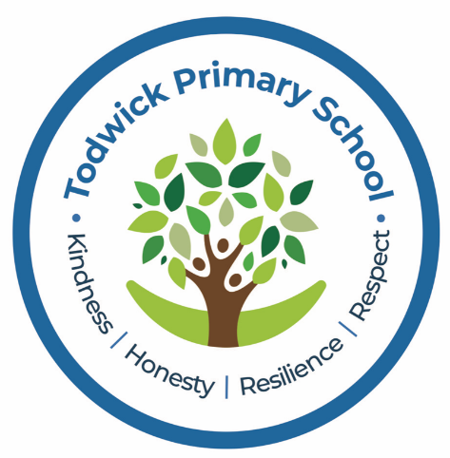

This school is a place where everyone has the right to be themselves. It’s a place where everyone can feel safe, be happy and learn. Everyone at our school is included and acts with respect and kindness towards each other. Our school takes bullying very seriously. Sometimes we don’t know if something bad is happening, so you need to tell us.

This policy looks at bullying, and what you can do when you feel you are being bullied, or when you notice someone else being bullied.

**We can help you by**:

* Helping you to know what bullying is.
* Teaching you what to do if you feel like you are being bullied, or if someone else is being bullied.
* Telling you names of grown-ups that you can speak to.



**What is bullying?**

A bully is someone who **hurts** another person **more than once**, by using behaviour which is meant to

**scare**, **hurt** or **upset** that person.

At our school, we use the word **‘STOP’** to identify bullying:

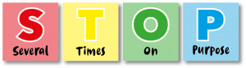

It is important to remember that **single problems** and **falling out with friends** are **not bullying**.

Bullying is behaviour which is **repeated** on purpose and is meant to **upset**someone.



**Types of bullying**

***Bullying can be different things and isn’t just hitting or kicking another person.***

* **Emotional bullying**is hurting someone’s feelings, leaving them out or bossing them about.
* **Physical bullying** is punching, kicking, spitting, hitting or pushing someone.
* **Verbal bullying** is teasing someone, calling them names or using hand signs.  People can also use verbal bullying to be **racist** or **homophobic**.
* **Racist**means bullying someone because of their skin colour, race or what they believe in.
* **Homophobic**means bullying someone because of their gender or sexuality; calling someone gay or lesbian would be homophobic.
* **Sexist**means bullying someone because of their sex (whether they are a boy or a girl).
* **Cyber bullying** involves sending unkind messages over the internet or by text message. 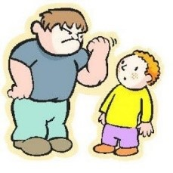

Bullying can be done through **another person**, by one person asking another person to say nasty things.



**What should I do if I am being bullied?**

If you are being bullied, the first thing you should do is tell the bully to **stop**. It is important to tell someone you trust. Tell an adult or friend, either at school or at home. If you have already told an adult about bullying you can still tell them again.

You should try not to:

* **Do** what the bully says.
* Let what the bully says or does **upset** you.
* Get **angry** or hit them.

Always remember that if you are being bullied, it is **not your fault** and you are **never alone**. You shouldn’t be scared to **talk to someone** if you are being bullied. If you talk to a grown-up, we can **make the** **bullying stop**.



**What should I do if I see someone else being bullied?**

In our school we all take responsibility in keeping each other safe. It is never OK to see someone being bullied and do nothing (being a bystander). You can tell people to stop (become a defender) or you can tell an adult about what has happened. If you think someone is being bullied then talk to the person, ask if they’re okay and ask if you can help them talk to a teacher or an adult they trust. You should **never feel scared** to tell someone about bullying.



**Who can I talk to?**

It is important that you **tell someone** as soon as you are being bullied, or you notice someone else being bullied.

Speaking to someone like your **mum**, **dad**, **carer** or **teacher** will mean that we can make sure the **bullying stops** and doesn’t happen again.

The list below shows the **grown-ups** at our **school** that you can speak to:

* Any adult in your classroom
* Mrs Deeley
* Mrs Perry
* SMSA

You can also call ChildLine at any time for free on 0800 1111. Childline is a free 24-hour counselling service for children and young people up to their 19th birthday. Whenever you need help, however you want to get in touch, they are there for you online, on the phone, anytime. It's confidential and you don't have to give your name if you don't want to. Confidentiality means not telling anyone else about what you've said. So whatever you say will be just between you and Childline and you can feel safe talking to them, knowing that no one else will find out. But sometimes, if they are worried about your safety, they may need to get you help.

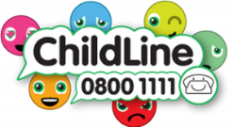

Useful support websites:

[www.counselling-directory.org.uk/bullying-advice-parents.html](http://www.counselling-directory.org.uk/bullying-advice-parents.html)   
[www.loudmouth.co.uk](http://www.loudmouth.co.uk/)   
[www.bullying.co.uk](http://www.bullying.co.uk/)   
[www.thinkuknow.co.uk](http://www.thinkuknow.co.uk/)   
[www.childline.org](http://www.childline.org/)