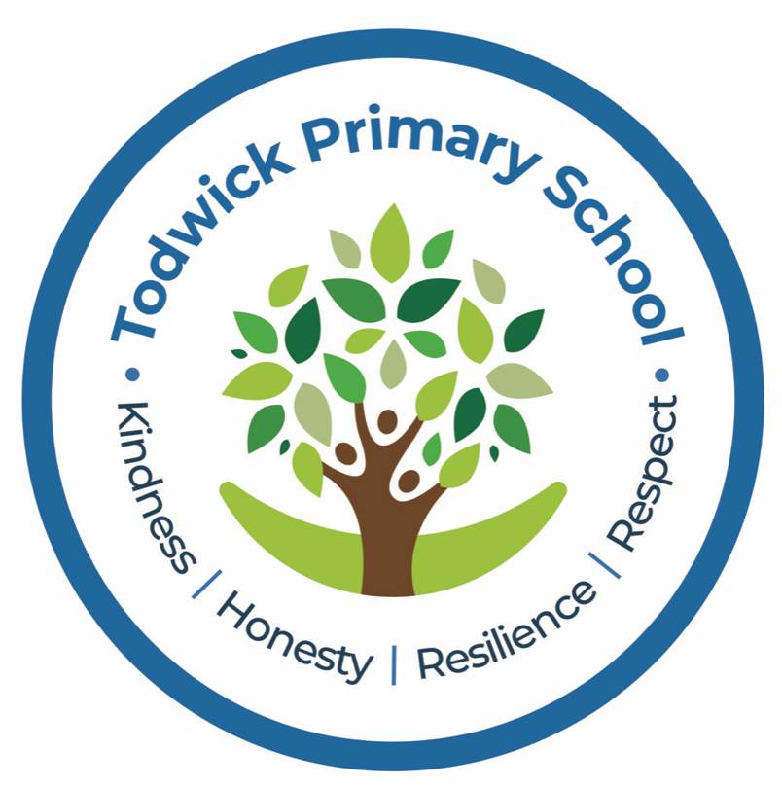

Todwick Primary School

Early Years & Foundation Stage Policy
September 2024

Review date: September 2025
Approved and adopted by the Governing Body

Member of staff responsible: Head Teacher

School Governor: Chair of Governors

Todwick Primary School
Foundation Stage Policy

The Early Years Foundation Stage (EYFS) applies to children from birth to the end of the
reception year. At Todwick Primary School children start in Class Foundation Stage 2, full time, in the September of the school year in which they are five.

The EYFS is based upon four principles:
• A Unique Child
• Positive Relationships
• Enabling Environments
• Learning and Development

A Unique Child

At Todwick Primary School we recognise that every child is a competent learner who can be resilient, capable, confident and self assured. We recognise that children develop in individual ways, at varying rates. Children’s attitudes and dispositions to learning are influenced by feedback from others; we use praise and encouragement, as well as celebration and rewards, to encourage children to develop a positive attitude to learning.

Inclusion
We value the diversity of individuals within the school and do not discriminate against children because of ‘differences’. All children at Todwick Primary School are treated fairly regardless of race, religion or abilities. All children and their families are valued within our school.

In our school we believe that all our children matter. We give our children every opportunity to achieve their best. We do this by taking account of our children’s range of life experiences and interests when planning for their learning.

In the EYFS we set realistic and challenging expectations that meet the needs of our children. We achieve this by planning to meet the needs of boys and girls, children with special educational needs, children who are more able, children with disabilities, children from all social and cultural backgrounds, children of different ethnic groups and those from diverse linguistic backgrounds. We meet the needs of all our children through:

• planning opportunities that build upon and extend children’s knowledge, experience and interests, and develop their self-esteem and confidence;

• using a wide range of teaching strategies based on children’s learning needs;

• providing a wide range of opportunities to motivate and support children and to help them to learn effectively;

• providing a safe and supportive learning environment in which the contribution of all children is valued;

• using resources which reflect diversity and are free from discrimination and stereotyping;

• planning challenging activities for children whose ability and understanding are in advance of their language and communication skills;

• monitoring children’s progress and taking action to provide support as necessary. It is important to us that all children in the school are ‘safe’. We aim to educate children on boundaries, rules and limits and to help them understand why they exist. We provide children with choices to help them develop this important life skill. Children should be allowed to take risks, but need to be taught how to recognise and avoid hazards. We aim to protect the physical and psychological well being of all children. (See Whole
School Safeguarding Children Policy)

Welfare

At Todwick Primary School we understand that we are legally required to comply with certain welfare requirements as stated in the Statutory Framework for Early Years Foundation Stage 2021. We understand that we are required to:
• promote the welfare of children.
• promote good health, preventing the spread of infection and taking appropriate action when children are ill.
• manage behaviour effectively in a manner appropriate for the children’s stage of development and individual needs.
• ensure all adults who look after the children or who have unsupervised access to them are suitable to do so.
• Ensure that the premises, furniture and equipment is safe and suitable for purpose
• Ensure that every child receives enjoyable and challenging learning and development experiences tailored to meet their needs.
• Maintain records, policies and procedures required for safe efficient management of the setting and to meet the needs of the children. We endeavour to meet all these requirements.

Positive Relationships

At Todwick Primary School we recognise that children learn to be strong and independent from secure relationships. We aim to develop caring, respectful, professional relationships with the children and their families.

Parents as Partners
We recognise that parents are children’s first and most enduring educators and we value the contribution they make.
We recognise the role that parents have played, and their future role, in educating the children. We do this through:

• talking to parents about their child before their child starts in our school;
• the children have the opportunity to attend taster sessions in Class FS2 before becoming full time in September;
• inviting all parents to an induction meeting during the term before their child
starts school;
• encouraging parents to talk to the child’s teacher if there are any concerns.

There is a formal meeting for parents in the Autumn and Spring terms at which the teacher and the parent discuss the child’s progress with the teacher. Parents receive a report on their child’s attainment and progress at the end of the Foundation Stage;

All staff involved with the EYFS aim to develop good relationships with all children, interacting positively with them and taking time to listen to them. At our school the EYFS teacher acts as a ‘Key Person’ to all children in EYFS, supported by the Teaching Assistants. Staff in the Foundation Stage 2 meet with the feeder pre-school settings to share good practice and discuss current issues.

Enabling Environments

At Todwick Primary School we recognise that the environment plays a key role in supporting and extending the children’s development. Through observation we assess the children’s interests, stages of development and learning needs, before planning challenging, achievable activities and experiences to extend the children’s learning.

Observation, Assessment and Planning
The Planning within the EYFS is based around half termly themes. These plans are used by the EYFS teacher as a guide for weekly planning, however the teacher may alter these in response to the needs (achievements and interests) of the children. This will be indicated on weekly planning. We make regular assessments of children’s learning and we use this information to ensure that future planning reflects identified needs. Assessment in the EYFS takes the form of observation, and this involves the teacher and other adults as appropriate. These observations are recorded in a variety of ways and used to inform the EYFSP.

During the first 6 weeks of Reception, each child will complete the statutory Reception Baseline Assessment alongside teacher assessments. Baseline information will be reported to parents during their Autumn term parent’s meeting.

Within the final term of the EYFS, we provide a written summary to parents, reporting their child’s progress against the ELG’s and their readiness for Y1.

The Learning Environment
The Foundation Stage classroom is organised to allow children to explore and learn securely and safely.
There are areas where the children can be active, be quiet and rest. The classroom is set up in learning areas, where children are able to find and locate equipment and resources independently.
The class has its own enclosed outdoor learning area with canopied area and a grassed area. This has a positive effect on the children’s development. Being outdoors offers the children further opportunities to explore, use their senses, develop their language skills and be physically active. We plan activities and resources both inside and outside enabling the children to develop in all the areas of learning.

Learning and Development

At Todwick Primary School we recognise that children learn and develop in different ways and have their own learning styles. We value all areas of learning and development equally and understand that they are often linked.

Teaching and Learning Style
Features that relate to the EYFS are:

• the partnership between teachers and parents, so that our children feel secure at school and develop a sense of well-being and achievement;
• the understanding that teachers have of how children develop and learn, and how this affects their teaching;

• the range of approaches used that provide first-hand experiences, give clear explanations, make appropriate interventions and extend and develop play and talk or other means of communication;

• the carefully planned curriculum that helps children work towards the Early Learning
Goals throughout EYFS;

• the provision for children to take part in activities that build on and extend their interests and develop their intellectual, physical, social and emotional abilities;

• the encouragement for children to communicate and talk about their learning, and to develop independence;

• the support for learning with appropriate and accessible indoor and outdoor space, facilities and equipment;

• the identification of the progress and future learning needs of children through observations;

• the good relationships between our school and the settings that our children experience prior to joining our school;

Play

Through play our children explore and develop learning experiences, which help them make sense of the world. They have the opportunity to practice skills, develop ideas and think creatively alongside other children as well as individually. The children communicate with others as they investigate and solve problems. They have the opportunity to express fears or re-live anxious experiences in controlled and safe situations.

Active Learning

“Children learn best through physical and mental challenges. Active learning involves other people, objects, ideas and events that engage and involve children for sustained periods.” Active learning occurs when children are motivated and interested. Children need to have some independence and control over their learning. As children develop their confidence they learn to make decisions. It provides children with a sense of satisfactions as they take ownership of their learning.

Areas of Learning
The EYFS is made up of seven areas of learning:
• Personal, Social and Emotional Development
• Communication and Language
• Physical Development
• Literacy
• Mathematics
• Expressive Arts and Design
• Understanding the World
None of these areas can be delivered in isolation from the others. They are equally
important and depend on each other. All areas are delivered through a balance of adult led and child initiated activities. In each area there are Early Learning Goals (ELG's) that define the expectations for most children to reach by the end of the EYFS.

Monitoring and review
It is the responsibility of the Foundation teacher to follow the principles stated in this policy. There is a named Governor responsible for the EYFS. This governor has the opportunity to discuss EYFS practice with the practitioners and provide feedback to the whole governing body, raising any issues that require discussion. The Head teacher and subject coordinators carry out monitoring of the EYFS through observation and discussion as part of the whole school monitoring schedule.

Mrs Emma Perry, Foundation Stage Coordinator

